How to create a Pipeline on SSIS
- Create connections with connection managers
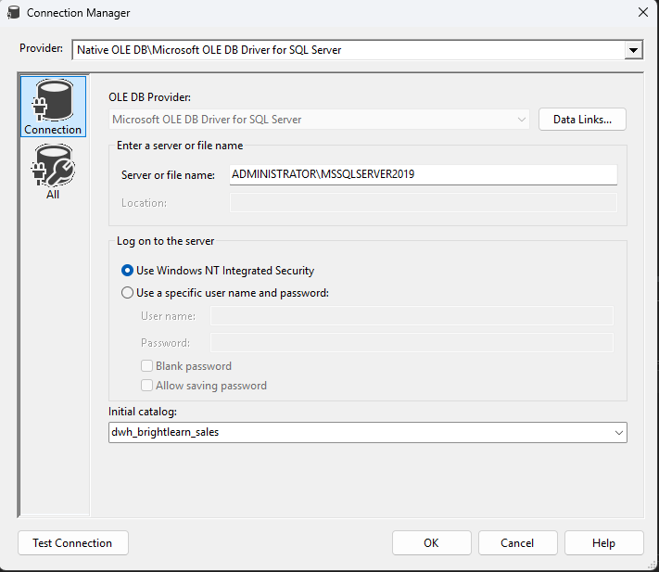
- Do data ingestion from source to destination
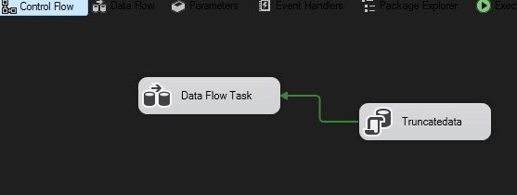
- Creating stg table and insert data
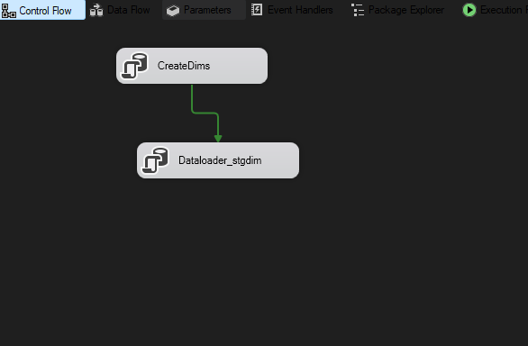
- Data clean up
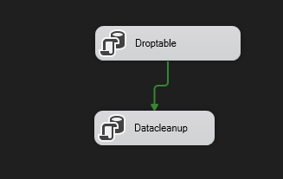
- Create dhw tables and insert data from a clean table
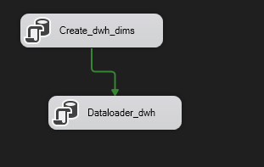
- Create a master package to run all the packages
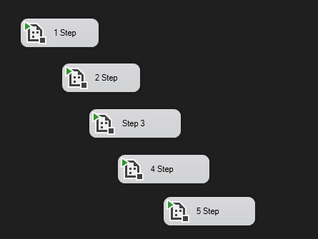
- Right click your Master deployment package the execute package
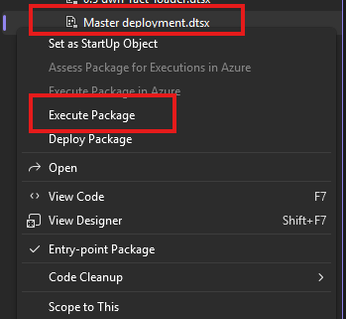

- Just make sure that all the processes ran successful
